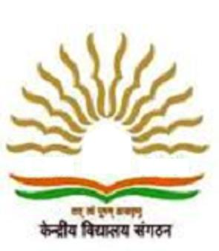
PM SHRI KENDRIYA VIDYALAYA NARANGI
Guwahati, Pin-781027

WALK IN INTERVIEW

Eligible and willing candidates may attend WALK- IN- INTERVIEW at PM SHRI KV Military Station Narangi for the following posts on purely Part Time Contractual basis as per KVS norms.

POST | Subjects | Interview Date
PRT/PRT Music | N/A | 28/02/2024  (8.00 AM)
BALVATIKA TEACHER | Qualification for Balvatika Teachers shall be as prescribed by NCTE.
PGT | Chemistry, Physics, Mathematics, Biology, Commerce, Economics, History, Political Science, Geography, English, Hindi, Computer science
TGT | Science, English, S.ST, Mathematics, Sanskrit, Hindi
Assamese Language Teacher | Assamese
Miscellaneous | Counsellor, Computer Instructor, ART & Craft, Coaches( Basketball) , Yoga Teacher , Nurse.
Special educator | Graduation ( Any stream ) with B.Ed. in Special Education or diploma in special education from institution recognized by Rehabilitation council of India (RCI)
Note:
- Minimum qualification and other details are available on the Vidyalaya website .https://narangi.kvs.ac.in
- Candidates may apply in advance through the below QR Code and can submit all other related documents with application form in hard copy on the day of interview 28.02.2024.
- The specific bio data application form is available on the website : .https://narangi.kvs.ac.in & also can be collected from school from the Vidyalaya on the day of Interview.
- Please do not send application through e mail.

Apply in Advance

-Sd/-
Principal

