STUDENT ACHIEVERS FROM CLASS X A
GANGA QUEST QUIZ PROGRAMME 2021

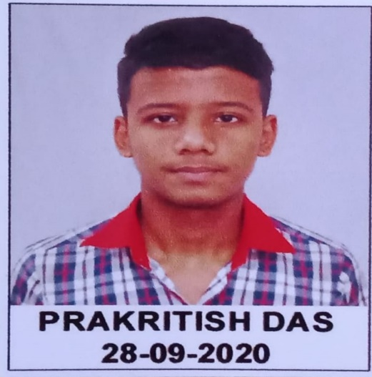
PRAKRITISH DAS, a student of class 10 A, has been one of the winners in top 25 weekly theme categories in Ganga quest Online quiz 2021. He is placed in 19th position under the theme “History-culture, Socio-economic” category. He won a cash prize of Rs 2500, a T-shirt, a medal and a certificate. Now he will be playing in the final rounds of Ganga Quest online Quiz 2021 under the same theme category.
Details of Prakritish Das
Father’s Name : Mr Prabhu Das
Adm no : 019026
DOB : 10/08/2005
Phone no .: 7002825637
Email: prabhughy@gmail.com

